## Hebrew Analysis Notes: Non-Categorized

Many languages including Hebrew have to be learned one point at a time until sufficient facts are gathered to form a concept. The following will be a list of singular points some relating some not, which will later be categorized in the proper way.

1. The Dages Lene Letters are: ב ג ד כ פ ת

2. The Dages Lene letters will not have the “dot” in them, if preceded by a vowel, and do not retain their hardened sound.

3. The Silent letters are: א ע

4. Letters having different form when they occur at the end of a word: כך  םמ  ףפ  ץצ  ןנ

5. The 5 Guttural letters are:   ע א  ח  ה  ר

6. These function differently than the regular consonants; they reject the Dages Forte.

7. Vowels: no vowel system was established until the 6th or 7th Century A.D.

8. Vowels are symbols, underneath or above the consonants.

9. Vowels listed as to whether they are Long or Short in tone and by Classification whether A Class, I Class, or U Class.

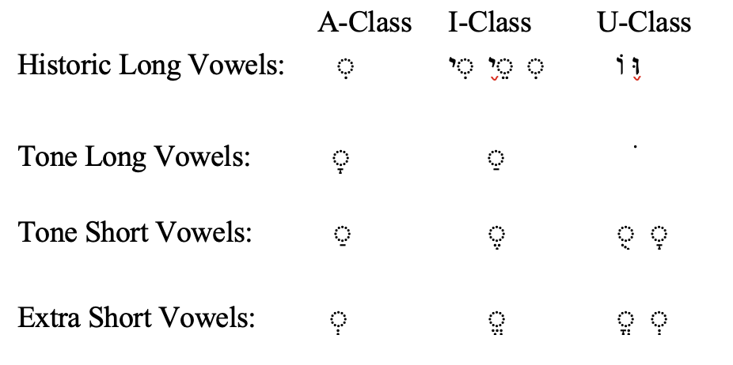

10. There are other Vowel Signs called Vowel Letters: ו י ה א

11. Vowel letters came before vowel signs of the system. The Massoretes used vowel letters and adapted Vowels to them.

12. There are five (5) Vowel Letters: hireq yod יִ , sere yod ֵי , holem waw וֹ , shureq וּ , and qametz he ָה .

13. All vowel letters are Long Vowels. Sometimes the consonants are removed but the vowels remain the same.

14. Syllabic Structure: every syllable must be with a consonant.

15. There is one exception to the above rule. This is the variant form of Waw, when beginning some words, some wrote וְ and some wrote וּ , therefore becoming a vowel.

16. One kind of syllable is called Open, this syllable ends with a vowel, or vowel letter.

17. The second kind of syllable is a Closed Syllable and ends with a consonant.

18. A doubly closed syllable ends with two consonants.

19. A Patac Furtive: When ה or ח or ע are final in a word and when preceded by a long vowel other than an A Class vowel, a Patac is placed under the above consonant or a little in front of it. This is used for aid in pronouncing and is pronounced before the consonant. ע א ח ה

20. The Shewa: this is two dots ְ placed under a consonant with a half-vowel sound or significance.

21. The Vocal Shewa occurs when it is pronounced, sounding like a short e, and hurried over.

22. The transliteration of the Vocal Shewa is the small e with a line over it.

23. The Compound Vocalic Shewa is used with Guttural letters which demand the Compound Shewa.

24. There are three (3) Compound Shewas: ֲ ֱ ֳ

ֲ Half sound short a

ֱ Half sound short e

ֳ Half sound short o

25. The Silent Shewa looks the same as the Vocal Shewa, but it is not pronounced.

26. The Silent Shewa is used within a word to indicate a closed syllable.

27. The Silent Shewa is used at the end of a word to indicate a doubly closed syllable.

28. There can be two Shewas occurring together under consecutive consonants, but not two vocal ones.

29. When two Shewas occur together, the first is always silent.

30. A Shewa at the beginning of a word is always vocal.

31. The two dots occurring in the final ךְ are not a Regular Shewa, but simply a sign of the final k from the final n.

32. A Vowel letter when Silent Quiscent, does not take the silent Shewa because they do not close the syllable. It may have a Compound Shewa and function as a consonant.

33. The Medium or Medial Shewa is used in the middle of a word and may be Vocal or Silent.

34. The Initial Shewa under the first consonant is always Vocal.

35. The Final Shewa is always Silent.

36. The Medial Shewa is Silent when it is preceded by a short unaccented Vowel; or followed by a consonant that has a Dages Lene; or followed by a consonant that has a Shewa.

37. The Medial Shewa is Vocal when it is preceded by a Meteg (֨) or the consonant it is under has a Dages.

38. A Dages Forte is a dot within a consonant to show that the letter is doubled.

39. The Dages Forte does not occur in Laryngeals: ע א ח ה ר

40. One reason that the Dages Forte occurs in a word is for the simple purpose of euphony.

41. Within a word a Closed Syllable whose final consonant has the Dages Forte is called a sharpened or strengthened syllable.

42. The Dages Forte is one of the characteristics for recognizing the Intensive stems.

43. The Dages Lene is a hardening dot which occurs within Begadkephat letters these are the same as listed as Dages Lene letters. The hardened sound is the sharp sound.

44. Normally a Dages Lene is used in Begadkaphat letters when they begin a word.

45. The exception to this is when a word immediately preceding, it ends in a vowel, the Dages Lene then may be dropped out, but the hard pronunciation is retained.

46. A Dages within a Begadkaphat letter may be Lene or Forte.

47. A Dages Forte always is preceded by a Vowel, never by a Shewa.

48. A Dages Lene is never preceded by a vowel, but always by a Silent Shewa.

49. There are some problems with the Guttural letters:  ע א ר they reject the Dages Forte and results in the preceding vowel to be lengthened.

50. There are problems with the Guttural Letters:   ח ה  they also reject the Dages Forte, but since then imply the Dages to be there, the preceding vowel does not lengthen.

51. All the Laryngeals (gutturals) take a compound Shewa and not a simple Shewa.

52. All the Laryngeals prefer an A Class vowel before them and they tend to demand the A Class after them.

53. Two Laryngeals א ח normally do not close a syllable. Will not occur where it would close a syllable.

54. There are over 30 kinds of accents for Hebrew words.

55. The three (3) basic functions of accents in Hebrew are: they mark the tone; they regulate the chanting of the text; and act as a mark of punctuation, to indicate the logical, syntactical relation of single words to their immediate surroundings and thus to the whole sentence.

56. There are two systems of Accents in the Hebrew, one for the Prose and another for the Poetry.

57. Every Hebrew word has one primary accent which usually occurs on the final syllable of the word, the Ultima, for the Tone Stress.

58. In the Kittel text the accent on the final syllable is not written, but it is there.

59. If the primary accent is not on the final syllable it is indicated by an accent sign somewhere else on the word.

60. In vocabulary form if the accent is not on the final syllable it will be ( ) over the first syllable.

61. In Kittel text it will be the Munach (֜) occurring under syllables other than the final syllable.

62. In addition to the Primary accent, there is a Secondary Accent. This is the Meteg וַיֵּחָלֵ֨ק (above the Lamed). This does not take the Primary accent away, but just emphasizes that you recognize that vowel and do not pass over it so rapidly.

63. When two or more words are joined into one accental unit, this mark occurs between them (־) and is called a Maqqeph. It joins them into one accented unit.

64. Accents are either Conjunctive or Disjunctive. Conjunctive accents join and show the relation; disjunctive accents separate and show separation.

65. One of the Disjunctive accents is the Athnach דָּבָ֑ר (mark under the Bet). This is used to show the primary verse division, usually in the middle of the verse. There will be a pause at this point sort of like a comma.

66. The end of a verse is indicated by two dots called a Soph Pasuq ׃ .

67. There is another accent which occurs only under the accented syllable of the last word in the verse. It is a Silluq and looks just like a meteg (֨) .

68. Regarding the last word in a verse: this primary accent when not indicated on the last syllable, the normal primary accent would be a Munah (֜) but not here, here it is a Silluq, and will be a Primary Accent ֽ .

69. Words in Pause: a syllable which receives the accents silluq ֽ atnaḥ ֑, are said to be in Pause. This will result in changing of the vowels within the word.

70. In the Hebrew there is no Indefinite article, or words equivalent to the English idea of “a”.

71. Usually a word without a definite article will receive an indefinite article in translation, the English letter “a” will be translated before the word.

72. The Definite Article is an Inseparable prefix to a word.

73. The Normal form of the definite article is הַ .

74. The form of the Definite Article changes before the Laryngeals.

75. Before the Laryngeals ע א ר the vowel of the article will be lengthened (in its own vowel class).

76. Before the Laryngeals ח and ה the vowel remains the same because these two letters imply the Dages.

77. Before the Laryngeals הַ and חַ the vowel under the article preceding these two letters will be the Ségol בֶ (the three dots under the Bet) .

78. Before the Laryngeals ה and נ when unaccented the above will be true also.

79. There are five words which do not follow the rules as stated above and in effect have radical vowel pointing.

80. Inseparable Prepositions are prepositions which are prefixed to words and not separate words in themselves. There are 3 of them: בְּ , in כְּ , as or like לְ , to, toward.

81. The normal form is prefixed before a consonant with a vowel and retains the Normal Shewa.

82. When the preposition is affixed to a word beginning with a Simple Shewa, the Shewa of the preposition becomes a Chireq (ִ)

83. When a word begins with a yod and vocal shewa, the shewa under the preposition loses its consonantal value and becomes a Chireq yod, therefore losing the shewa originally under the yod.

84. When a preposition is prefixed to a compound shewa the preposition takes the vowel sign of the compound shewa and is written with a meteg (֨) .

85. When a preposition is prefixed to a word which has the definite article the preposition loses its shewa, take the vowel of the article and supplants the ה of the article.

86. A preposition before an accented syllable, sometimes takes a ָ.

87. The preposition מִן comes from or out of and it may be Separable or Inseparable.

88. The Separable מִן usually occurs before a word with the Definite Article and also is written with a Maqqeph (־) normally.

89. The Hebrew Verb has certain characteristics: in Greek a verb has tense, voice, mood, person and number, so in Hebrew it has a number of factors.

In Hebrew a verb has: Stem: this indicates the particular relation of the subject to the action and describes the type of action. It may be Simple action, Intensive action, or Causative action.

Tense: this indicates the quality of Action as Incomplete or complete. Time is not a factor, though it is included as it is in Greek.

Number: it is either singular or plural

Person: it is first, second or third person as in Greek, though the order is reversed.

Gender: the gender is indicated by the type of form of the verb, rather than the context of the sentence. In Greek, the first person singular, I, has to be determined in context whether it is feminine or masculine. In Hebrew it is determined by its suffix endings.

Classifications: all verbs fall into certain types of classifications. In Greek, verbs fall into certain types of conjugations. These conjugations are determined by unifying factors of the verbs including root, prefix, suffix. In Hebrew the classifications are normally based on the Root, the Vowel Pattern, etc.

Etymology: one of the interesting characteristics of the Hebrew verb is that the etymology of a word sometimes changes totally when it moves from stem to stem. This is not an interpretative idea; this is actually a new meaning.

Sentence Significance: a verb may be, as it stands alone in a sentence or verse, a given tense; but actually function as another tense. It will be recognized in form as one thing but in translation it will hold another meaning.

90. There are seven regular Verb Stems in the Hebrew, and the Stative Verb. in the Strong verb as well.

Qal stem: this is the simple active in function.

Niphal stem: this is the reflexive and the passive function.

Piel stem: this is the intensive active, however, not all that occur in Piel are intensive.

Pual stem: this is the intensive passive.

Hithpael stem: this is the intensive reflexive.

Hiphil stem: this is the causative active.

Hophal stem: this is the causative passive.

The Stative Verb: this is the state of being verb. (was, will be, etc.)

91. The tense of a verb in the Hebrew, whether Perfect or Imperfect is indicated with certain distinguishing characteristics. However, these characteristics undergo some changes at times that would tend to disguise them. The Imperfect in all stems have a pronominal preformative, or prefix attached to the beginning of the word that distinguishes it from the Perfect. These will be indicated later. The Perfect does not have these, with the exception of the Hiphil and Hophal in the causative function.

92. There are several things that one needs to do to learn well the verbs. The purpose in baby Hebrew is to be able to recognize them. We will learn facts about the verb in the following order: What tense is it? What stem is it? What number is it? What person and gender is it?

93. This process is helped by using the following technique of learning. The first step is to:

Find the Root of the Verb: To do this, you may: Identify any suffix ending that is there that you know. Identify any prefix performative that you may know. In most cases find the three consecutive consonants that are excluded from the suffix or prefix.

Find the Vowel Pattern: The Vowel Pattern will be learned for the Perfect and Imperfect. Vowel patterns will be learned for the Verb stem. So, you have a two-fold idea in the matter of vowel pattern, that of the tense and that of the stem. The pattern of vowel will be determined also by the class of verb which it falls into.

Find the Distinguishing Stem Characteristics: most of the Hebrew stems have their own particular stem characteristics. These will be learned one at a time and you will have time to assimilate them.

Learn immediately where in your tools to find the listings of forms and pointings that will enable you to double check what you have found.

Remember carefully that there is a basic set of Suffixes for the Perfect tense that carries through each stem. There is a basic set of Suffixes for the Imperfect tense, which also carries through the stems. If you learn these you will be able to recognize the two factors of Gender or Number immediately.